Application Date
Application Details
CERTIFICATE REQUESTED BY
Company Name
Company Address
Company Authority
Title
Phone
Fax
E-mail
Web Address
Tax Office
Tax Office Number
CERTIFICATE REQUESTED PRODUCT
Basic Certification Document (Standard/Specification/Criteria)
Trade Mark

Trade Model (If any) | Product Name | Product Specifications (Class, type, no, etc.)
* Use additional sheet if necessary.
** Technical data sheet and drawing are needed for each product.

CERTIFICATE REQUESTED
 | CERTIFICATION TYPE | REGISTRATED MARKS
☐ | CE Certificate | 
☐ | ENEC Certificate | 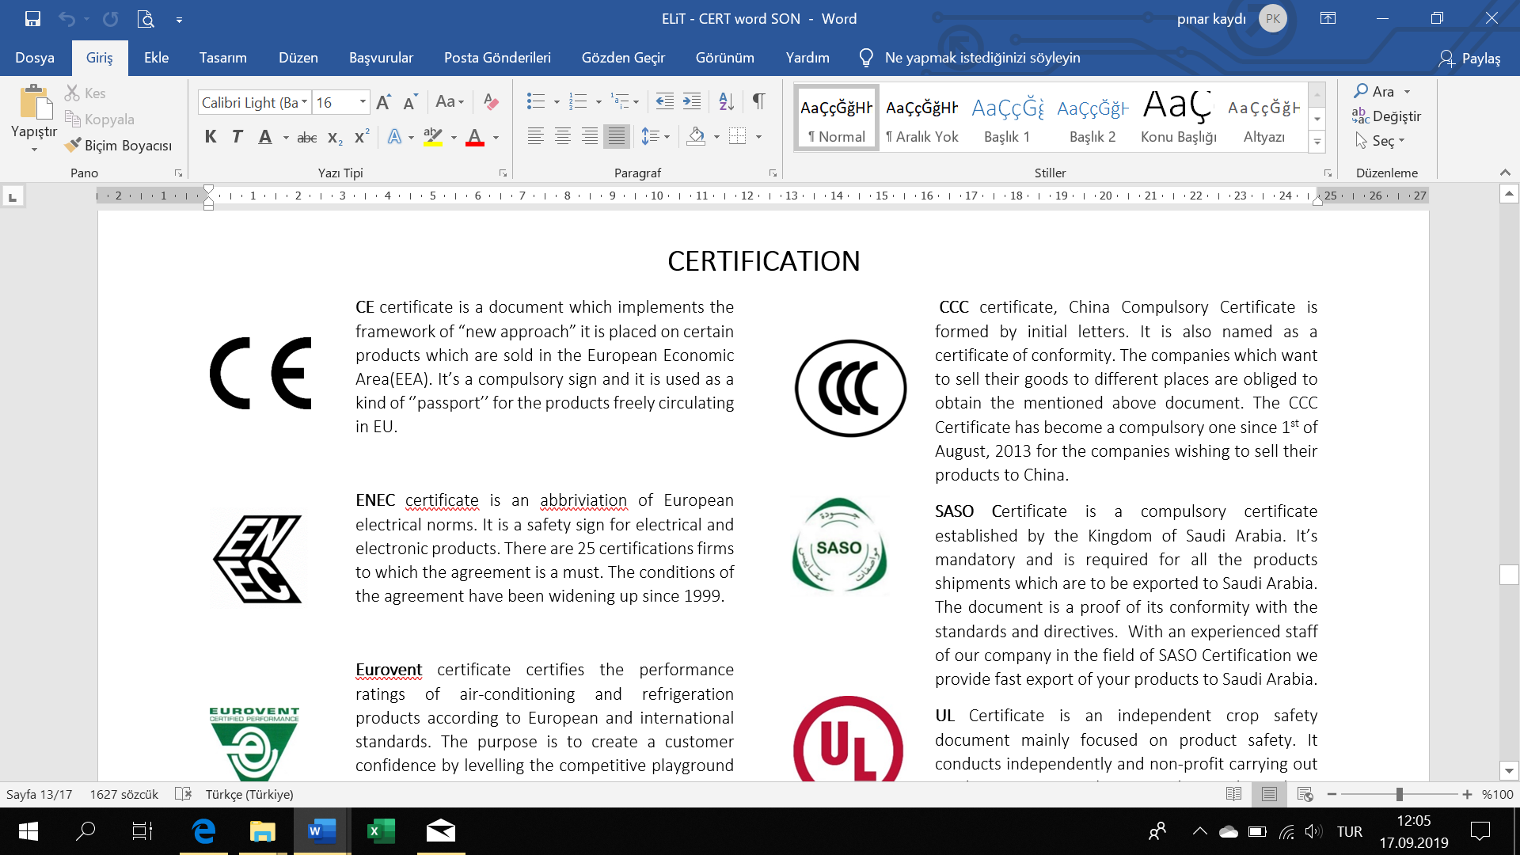
☐ | CCC Certificate | 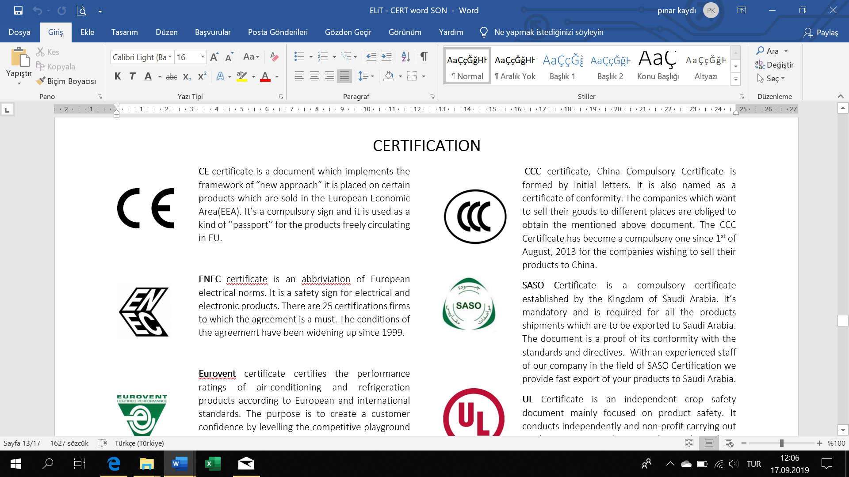
☐ | SASO Certificate | 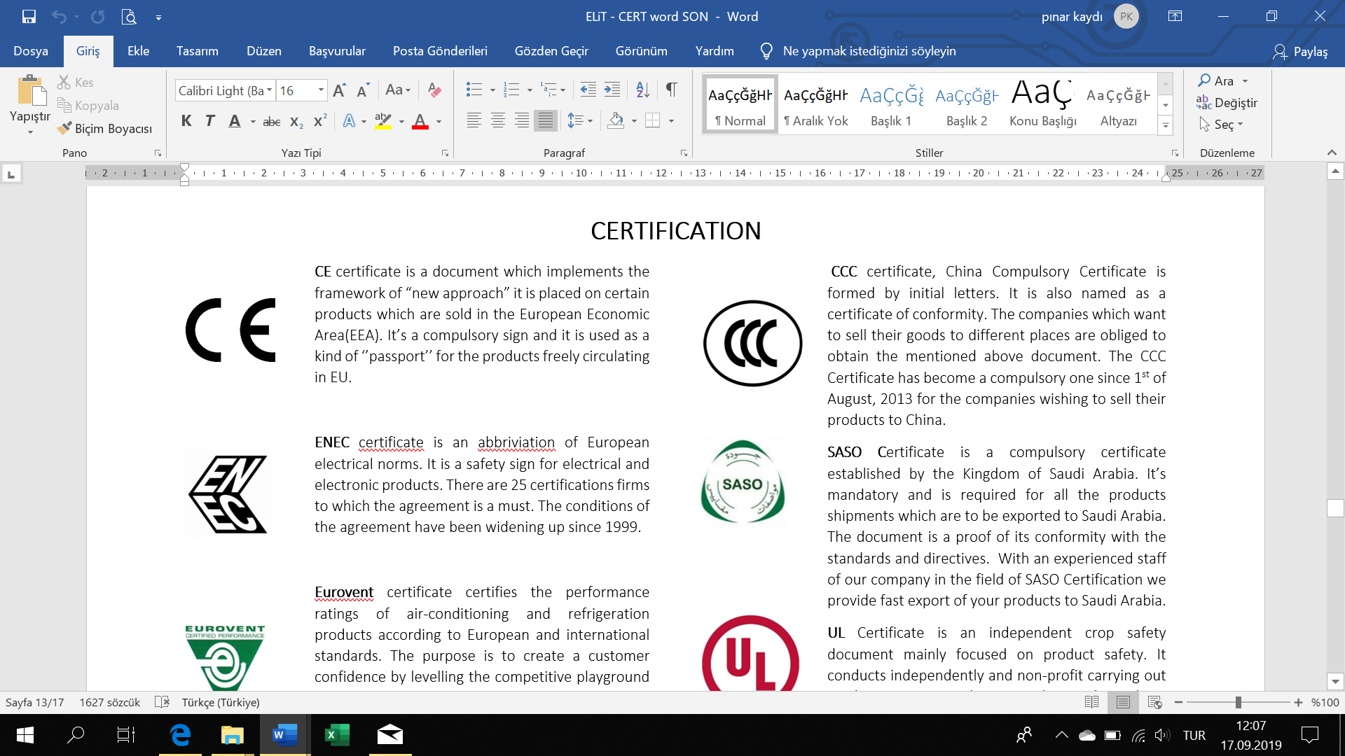
☐ | UL Certificate | 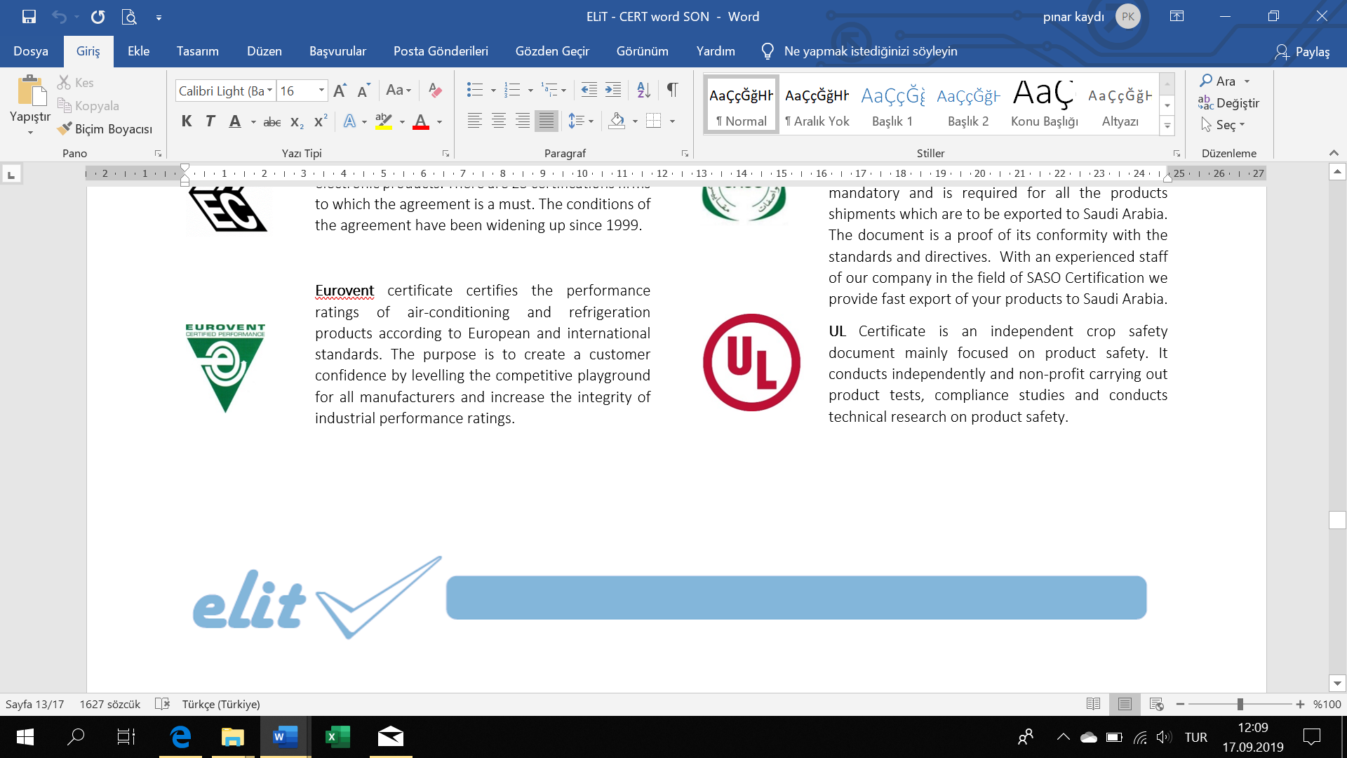
☐ | RoHS 3 Certificate | 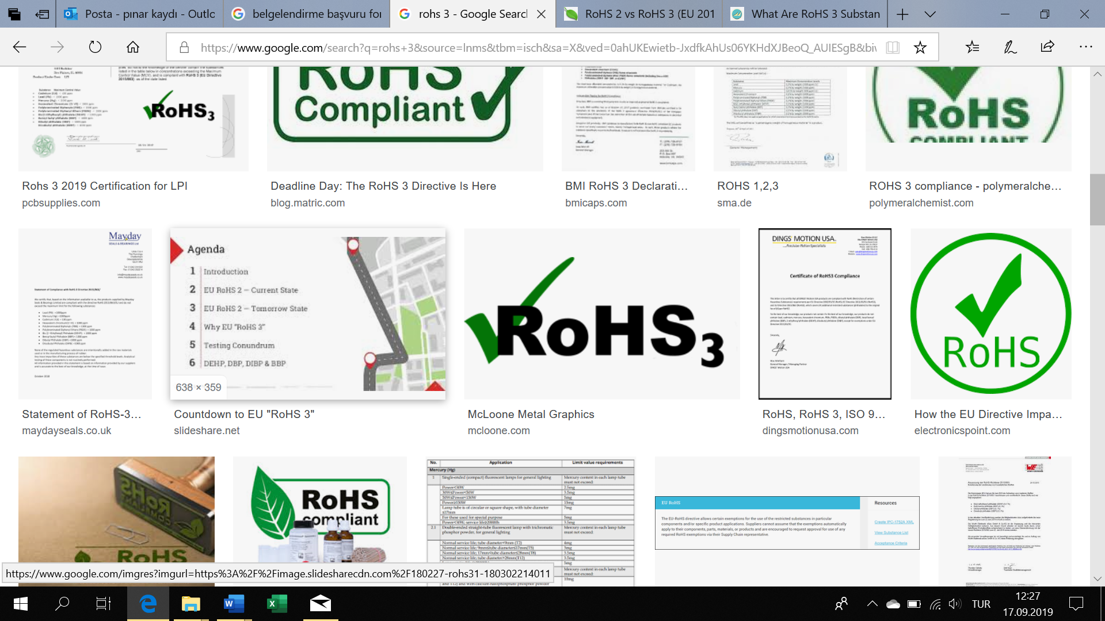
☐ | Eurovent Certificate
☐ | IEC Certificate | 
☐ | UkrSEPRO Certificate | 
☐ | GS Certificate | 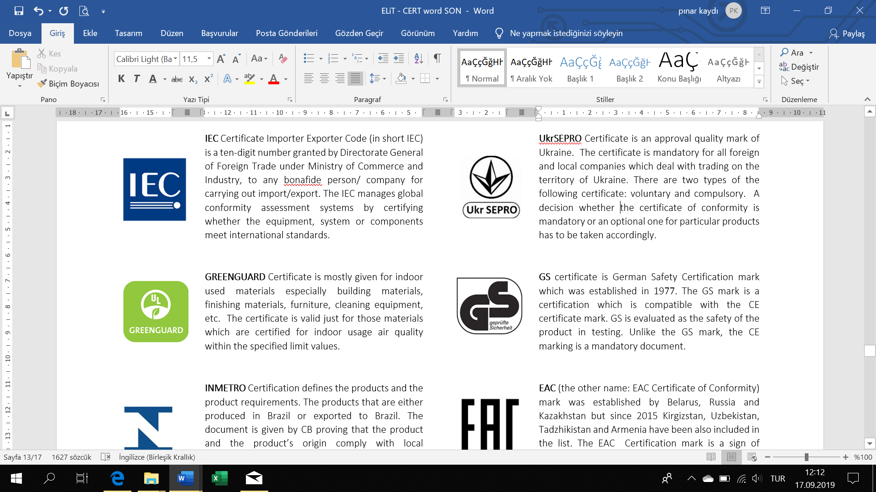
☐ | EAC Certificate of Conformity | 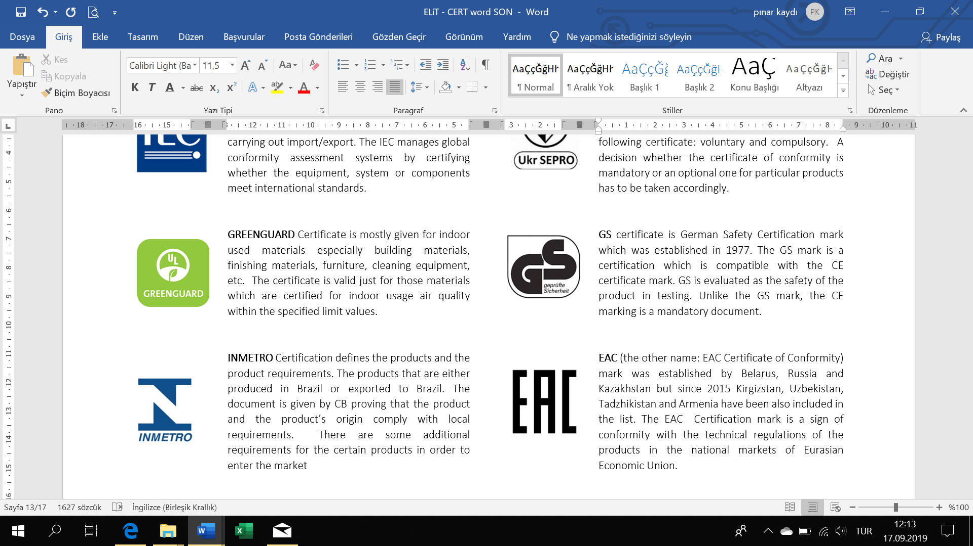
☐ | KEMA Certificate | 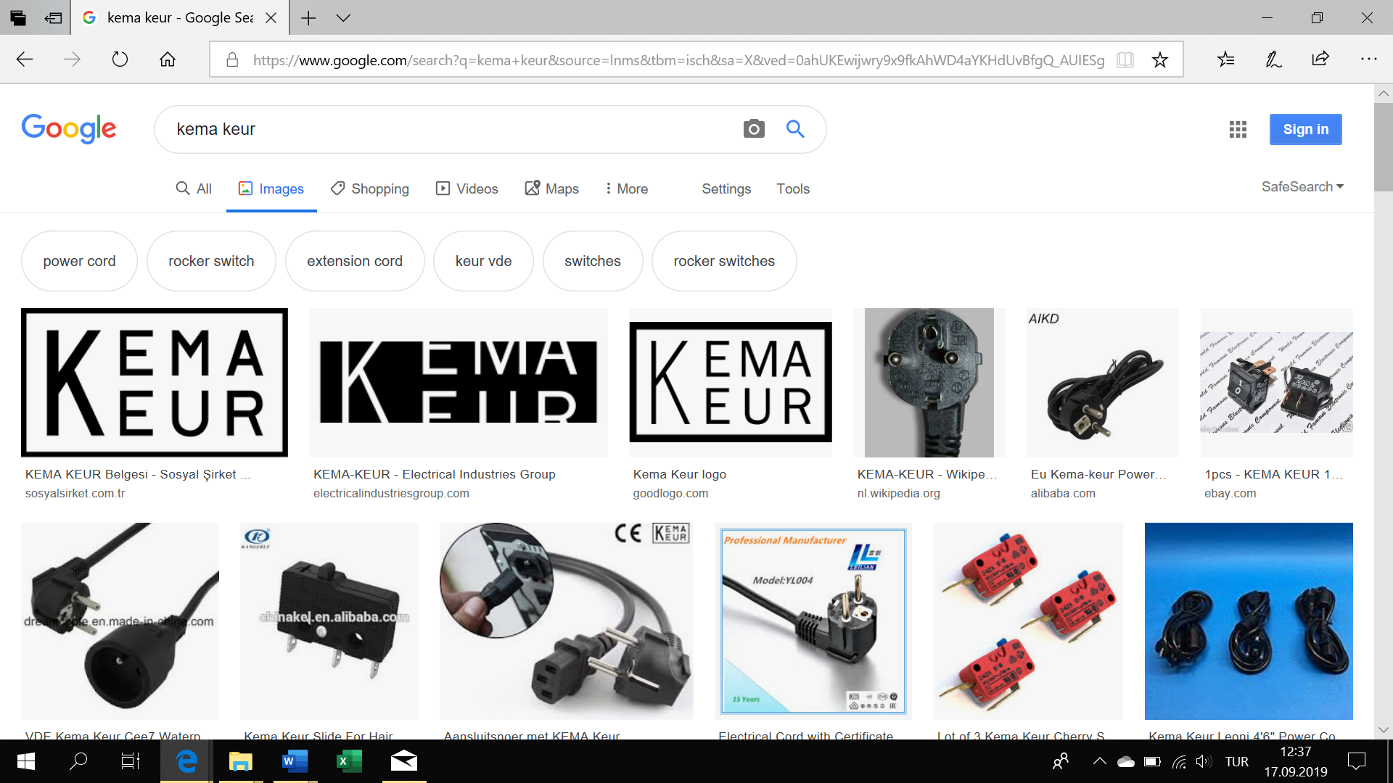
☐ | CEBEC Certificate | 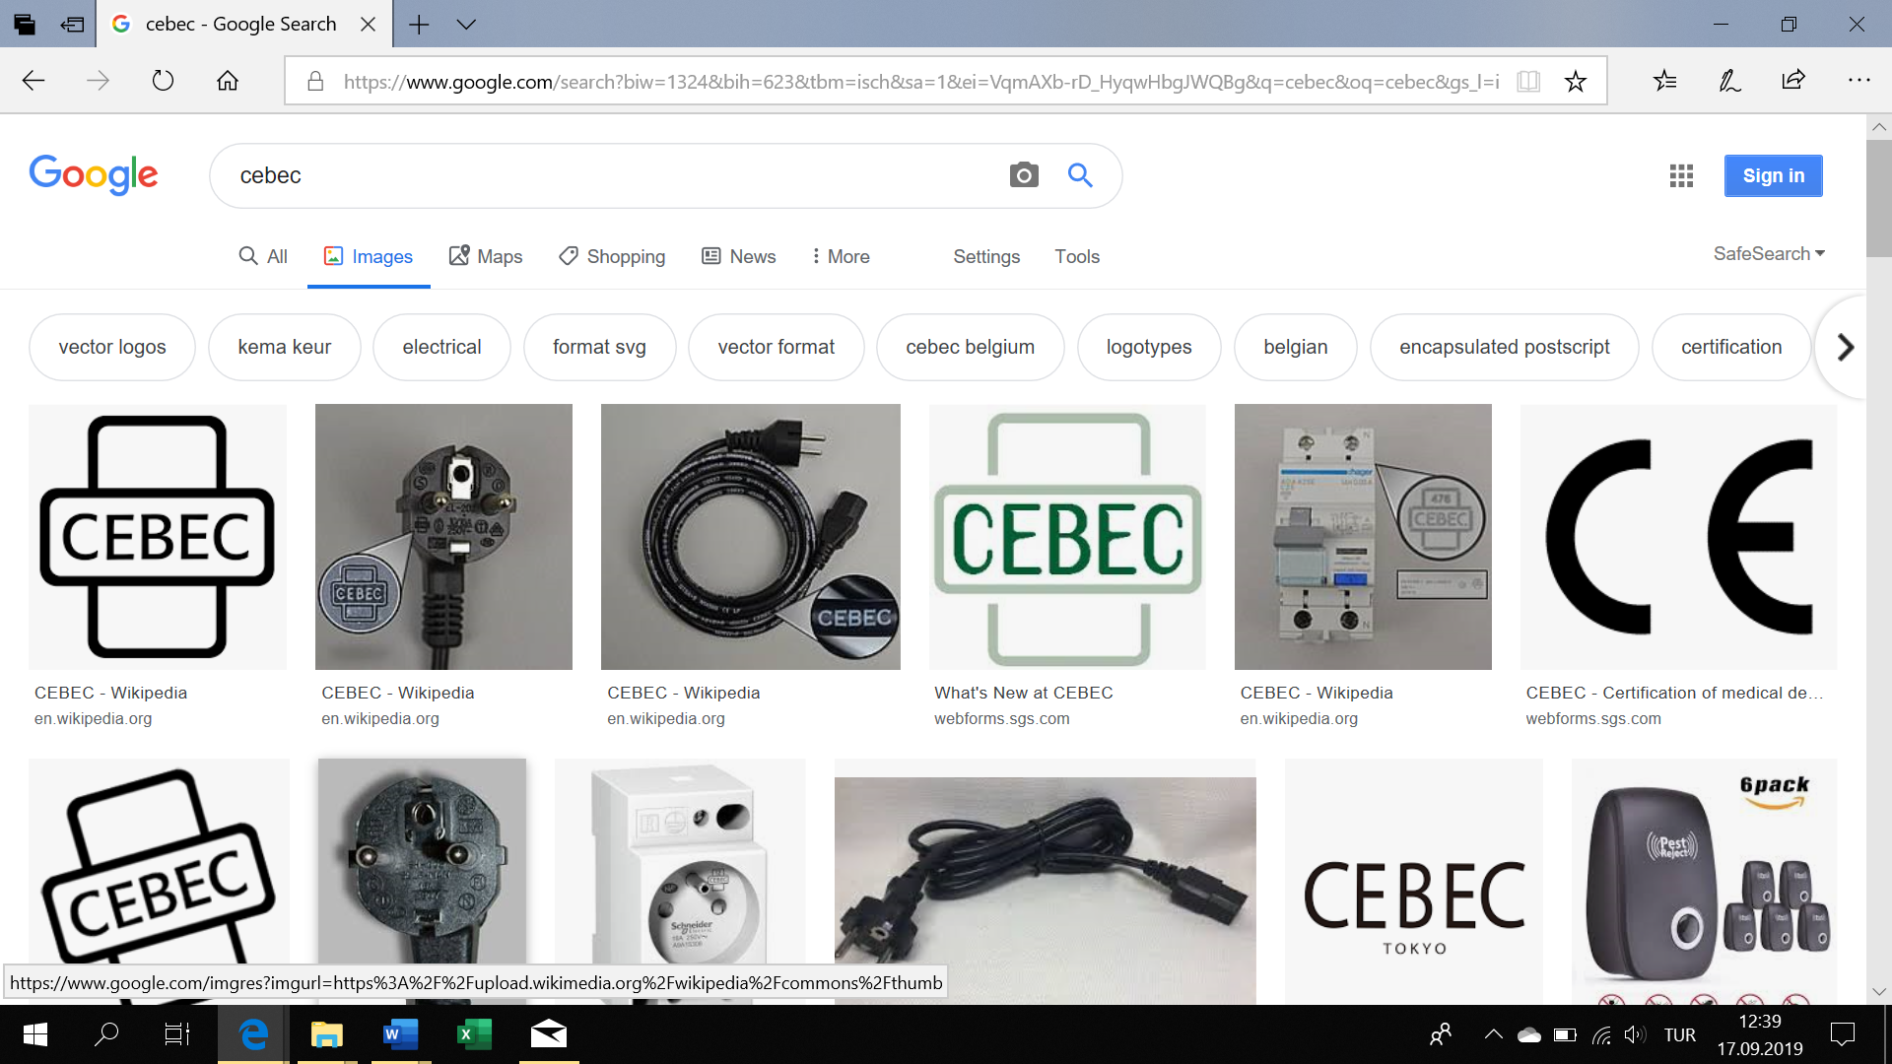
☐ | Test Certificate
☐ | Type Test Certificate
☐ | Factory Production Control Certificate
☐ | CPR Test Report
☐ | Other

TYPE OF EVALUATION REQUESTED
☐ | First Application (New Certification) | ☐ | Standard/Criteria Changes
☐ | Scope Expanding | ☐ | Scope Narrowing
☐ | Manufacturing Place Changes | ☐ | Status/Title Change
☐ | Address Changes | ☐ | Trade Mark Change
☐ | Other

TEST SPECIMENTS
☐ | ready | ☐ | will be ready on ..…/..…/…….

1. The form must be filled in very carefully by the applicant or his / her authority and each page must be initialled. This form is designed to understand the conditions of the organizations and to avoid any differences in understanding in the future.
2. All information will not be disclosed to third parties without the permission of the organizations.

Authorized Name / Surname: Signature / Stamp

Date:

